CSC 120 Midterm

This is an open book exam. What this means is you can refer to online material, book for this exam. However, to get all the credits please make sure that you cite the references for every answer. You can cite the webpage url or the text book name and chapter details as a reference. The aim of this assignment is to help you become self learners. It will test your understanding of basics and how you apply the basics to new scenarios. We are moving away from a learning style which is only memory based and trying to develop skills to learn any new skill by using all the resources available. Make sure you attempt everything as there are points for attempting. Good luck!

Part A Conceptual Questions

* (+2) In an 8 bit number 10101000. What is the MSB (Most Significant Bit)? Which bit is the LSB (Least Significant Bit)

(MSB)10101000 (LSB)

* (+2) In the 2's complement system, if there is a number 1000, what does the 1 represent?

The negative sign

* (+6) Convert the following 2's complement to its equivalent base 10 form (decimal)

00011 (2+1) = (3)10

11100 (11100)

00011

1 +

00100 = (4)10

11010 (11010)

00101

1 +

00110 = (2+4)10 = (6)10

* (+4) Why is the 2's complement system used? it used because it gives an advantage of addition, subtraction and multiplication without special logic, so the negative binary number act just like positive number.
* (+6) What is the difference between signed binary integers and unsigned binary integers? When would you use each? If you had a 6-bit binary number how many decimal numbers can be represented with it if you were using a signed binary?

signed binary integers: numbers with positive or negative sign, but unsigned binary does not have any.

We would use signed binary integers in python (int)to represent (-,+)sign. Also, we can use it in 1’s complement, 2’s complement, and sign magnitude, while unsigned binary we can use it in unambiguous.

5-bits binary because the (MSB) is going to be for the sign.

* (+5) You have an 8-bit binary number 11110000. What happens when you AND this number with any other 8-bit number. Try out a few examples and try to generalize your observations.

It will end with zeros unless one of the first four numbers of the other number is one.

* (+5) You have an 8 bit binary number 00001111. What happens when you OR this number with any other 8 bit number. Try out a few examples and try to generalize your observations.

It will end with eight ones unless one of the first four numbers of the other number is zero.

* (+5) You have an 8-bit binary number 11111111. What happens when you XOR this number with any other 8-bit number. Try out a few examples and try to generalize your observations.

It will end up with flipping the other bit number, so it will flip each zero with one and each one with zero.

* (+5) Write a Python program to add two numbers by getting inputs from the user. Paste a screenshot of the code from Google colab.

the_number = input('Please enter a number')  
the_number1 = input('Please enter a number')  
a = int(the_number) + int(the_number1)  
print(a)

* (+10) In Python, consider the following code sample,

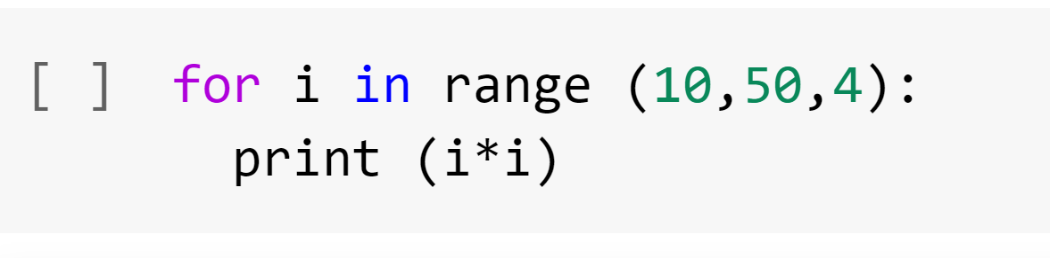

1. What does 10 represent? Initialization (start value)
2. What does 50 represent? (condition)
3. What does 4 represent? (increments)
4. What gets printed?

100

196

324

484

676

900

1156

1444

1764

2116

* (+5) In Python consider the code below what value would be printed by the following operation. Why? 3 since the instruction asked to print b which is represent the remainder of (87%7). 12.428571428571429 since the instruction asked to print c which is (87/7).

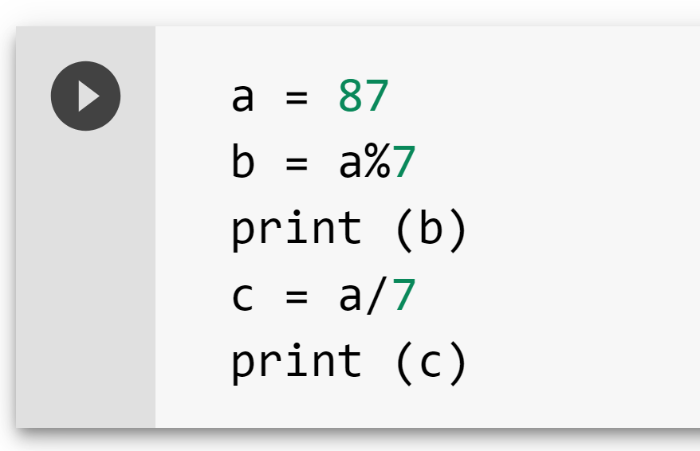

* (+5) In the VOLE architecture describe a sample instruction in terms of an opcode and an operand with an example.

Opcode is 2 and operand is RXY which means load the register R with the bit pattern XY.

For Example: 23B4 would cause the value B4 to be placed in register 3.

* (+10) What is an IO bound process vs a compute bound process? In case an IO bound process is waiting on an operation what happens? What is the role of the kernel and the scheduler in this event? Write your own interpretation by reading the book/online. Cite references.

IO-bound process (input/output) which communicate with the external system. While compute-bound process is that when the program execution correlated to the CPU, such as math problems. While an IO-bound process is program that its performance correlated to subsystem such as word processor.

IO wait will tell the CPU to pause the executing of the current thread till all data being available from the sources, and will go to the next thread, so this will make many threads sleeping while IO waiting. This will make the application running low since there are few threads left.

I/O scheduler role in this event is to let the CPU go the next thread

* (+5) How slow is main memory compared to CPU register? How slow is fetching from a hard drive as compared to main memory? Research online and provide references.

Main memory/RAM is much slower than CPU registers. The processing speed of CPU can be increased by increasing the amount of memory.

The process of an operation is that the CPU sends, and fetches program data and instructions will be transferred to the hard drive. Because the RAM is way faster than the hard drive, so the memory using in an operation from it.

Part B Exploration (15 points)

In Python, when do you use a for loop vs a while loop? Provide examples of each. Research online on when a while loop is more suitable to use than a for loop. Cite your sources as references.

For loop is used in a piece of code that we want to repeat it for several times as the user wants. It also depends on the elements it must repeat. While Loop is used to repeat a block of code and it depends on the condition of (true) which will repeat the loop, and (false) which will stop the loop. Also, it executes set of statements several times till the condition become false.

X = 5

While (x <9):

Print(x)

X = x+ 10

X = 0

For I in range (2,60):

If I % 2 == 0:

Print (I)

X = 0

For I in range (0, 22, 88):

Print(i+3)

i = 7  
while i < 20:  
  print(i) we can see here that while loop act as a holder   
  if i == 3: to for loop which is inside it, so while loop   
    break is bigger in action.  
  i += 1

Part C General Awareness (10 points)

Read the following article.

https://uhs.princeton.edu/health-resources/ergonomics-computer-use

What guidelines are you currently following? What guidelines are you not following? List all changes that you plan to make over the next few weeks to improve your posture.

Following

1. Monitor position.
2. Chair position

Not following

1. I am not sitting in Comfortable, Healthy Workstation
2. I overwork the muscles of my eyes.
3. I do not protect my back and neck.

Changes

1. I would take breaks more often at least for 15 minutes every one hour and blink my eyes.
2. I would choose a comfortable chair as I am using it for long hours.
3. I will avoid laying on my belly as I got back pain while working on my laptop.

Instructions: Upload the file with your firstname_lastname on Blackboard.

Works Cited

https://en.wikipedia.org/wiki/Two%27s_complement#:~:text=Compared%20to%20other%20systems%20for,in%20the%20same%20number%20of

<https://www.electronics-tutorials.ws/binary/signed-binary-numbers.html>

https://www.guru99.com/python-loops-while-for-break-continue-enumerate.html

<https://www.tutorialspoint.com/unsigned-and-signed-binary-numbers>

<https://techtorium.ac.nz/the-difference-between-ram-and-hard-drive/>

<https://techdifferences.com/difference-between-register-and-memory.html>

https://www.hellsoft.se/understanding-cpu-and-i-o-bound-for-asynchronous-operations/